CSE520
Samuel Marrujo
Professor Yu
Lab 01

Draw01
In this part of the lab, it was a simple compilation of two programs. I was able to accomplish this task successfully. Here are my results for this program:
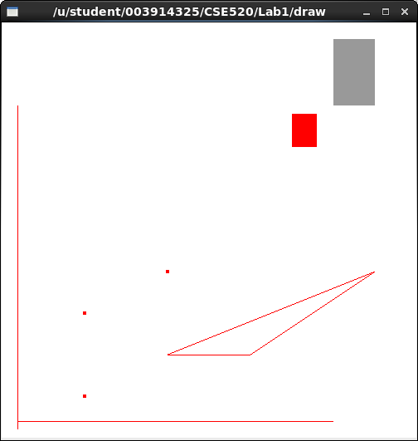

//draw.cpp : demo program for drawing 3 dots, two lines, ploylines, rectangles
#include <GL/glut.h>

//initialization
void init( void )
{
glClearColor( 1.0, 1.0, 1.0, 0.0 ); //get white background color
glColor3f( 0.0f, 0.0f, 0.0f ); //set drawing color
glPointSize( 4.0 ); //a dot is 4x4
glMatrixMode( GL_PROJECTION );
glLoadIdentity(); //replace current matrix with identity matrix
gluOrtho2D( 0.0, 500.0, 0.0, 500.0 );
}

void display( void )
{
glClear( GL_COLOR_BUFFER_BIT ); //clear screen
glBegin( GL_POINTS ); //draw points
glVertex2i( 100, 50 ); //draw a point
glVertex2i( 100, 150 ); //draw a point
glVertex2i( 200, 200 ); //draw a point
glEnd();
glBegin( GL_LINES ); //draw lines
glVertex2i( 20, 20 ); //horizontal line
glVertex2i( 400, 20 );
glVertex2i( 20, 10 ); //vertical line
glVertex2i( 20, 400 );
glEnd();
glBegin( GL_LINE_STRIP ); //draw polyline
glVertex2i( 200, 100 );
glVertex2i( 300, 100 );
glVertex2i( 450, 200 );
glVertex2i( 200, 100 );
glEnd();
glColor3f( 0.6, 0.6, 0.6 ); //bright grey
glRecti( 400, 400, 450, 480 );
glColor3f( 1.0, 0.0, 0.0 ); //red
glRecti( 350, 350, 380, 390 );

glFlush(); //send all output to screen
}
//------------------------------------------------------------------------------

//draw_main.cpp: main loop of drawing program

#include <GL/glut.h>
#include <math.h>
#include <stdlib.h>
#include <stdio.h>

//initialization
void init(void);
//does the drawing
void display(void);

/* Main Loop
* Open window with initial window size, title bar,
* RGBA display mode, depth buffer.
*/
int main(int argc, char** argv)
{
glutInit(&argc, argv); //initialize toolkit
glutInitDisplayMode (GLUT_SINGLE | GLUT_RGB ); //set display mode: single bufferring, RGBA model
glutInitWindowSize(500, 500); //set window size on screen
glutInitWindowPosition( 100, 150 ); //set window position on screen
glutCreateWindow(argv[0]); //open screen window
init();
glutDisplayFunc (display); //points to display function
glutMainLoop(); //go into perpetual loop
return 0;
}
Mouse_key
Lastly, in the mouse_key program, we are to modify the program to how we want it. So, I decided to change the brush size and the color, then decided to draw a happy face afterward! Here are my results for this program:
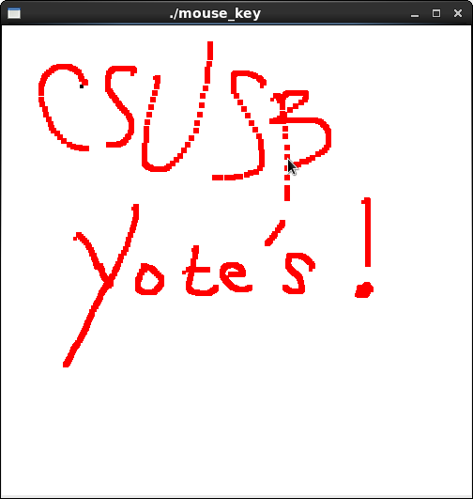

//mouse_key.cpp
#include <GL/glut.h>
#include <stdlib.h>

#define screenHeight 500

//initialization
void init( void )
{
glClearColor( 1.0, 1.0, 1.0, 0.0 ); //get white background color
glColor3f( 0.0f, 0.0f, 0.0f ); //set drawing color
glPointSize( 4.0 ); //a dot is 4x4
glMatrixMode( GL_PROJECTION );
glLoadIdentity();
gluOrtho2D( 0.0, 500.0, 0.0, 500.0 );
} //init

void display()
{
glClear( GL_COLOR_BUFFER_BIT | GL_DEPTH_BUFFER_BIT );
glFlush();
}

void drawDot( int x, int y )
{
glBegin( GL_POINTS );
glVertex2i( x, y ); //draw a point
glEnd();
} //drawDot

void myMouse( int button, int state, int x, int y )
{
if ( button == GLUT_LEFT_BUTTON && state == GLUT_DOWN )
drawDot( x, screenHeight - y );
glFlush(); //send all output to screen
}

void myMovedMouse( int mouseX, int mouseY)
{
GLint x = mouseX;
GLint y = screenHeight - mouseY;
GLint brushsize = 6;
glColor3f( 1.0, 0.0, 0.0 );
glRecti ( x, y, x + brushsize, y + brushsize );
glFlush();
} //myMovedMouse

void myKeyboard ( unsigned char key, int mouseX, int mouseY )
{
GLint x = mouseX;
GLint y = screenHeight - mouseY;
switch( key )
{
case 'p':
drawDot ( x, y );
break;
case 'e':
exit ( -1 );
default :
break;
}
}

//mouse_key_main.cpp: main loop of drawing program

#include <GL/glut.h>
#include <math.h>
#include <stdlib.h>
#include <stdio.h>

//initialization
void init(void);
void myMouse( int button, int state, int x, int y);
void myMovedMouse( int mouseX, int mouseY);
void myKeyboard ( unsigned char key, int x, int y );
void display( void );

/* Main Loop
* Open window with initial window size, title bar,
* RGBA display mode, depth buffer.
*/
int main(int argc, char** argv)
{
glutInit(&argc, argv); //initialize toolkit
glutInitDisplayMode (GLUT_SINGLE | GLUT_RGB ); //set display mode
glutInitWindowSize(500, 500); //set window size on screen
glutInitWindowPosition( 100, 150 ); //set window position on screen
glutCreateWindow(argv[0]); //open screen widow
init();
glutMouseFunc( myMouse );
glutMotionFunc( myMovedMouse );
glutKeyboardFunc( myKeyboard );
glutDisplayFunc( display );
glutMainLoop(); //go into perpetual loop
return 0;
}
Draw lines
In this part of the lab, I constructed a program that creates a point from a click, and can draw a line from a left-button click. This program also can be exited by pushing the esc button. Furthermore, the 'o' button toggles whether you can draw lines, or draw points. I have accomplished all that is needed for this lab. Here are the results:

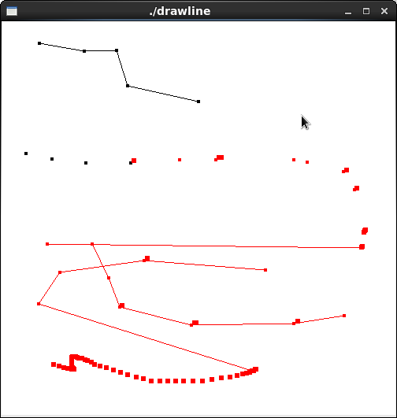

//mouse_key.cpp
#include <GL/glut.h>
#include <stdlib.h>

#define screenHeight 500

bool connect = true;
GLint x_1 = -1, y_1 = -1;

//initialization
void init( void )
{
glClearColor( 1.0, 1.0, 1.0, 0.0 ); //get white background color
glColor3f( 0.0f, 0.0f, 0.0f ); //set drawing color
glPointSize( 4.0 ); //a dot is 4x4
glMatrixMode( GL_PROJECTION );
glLoadIdentity();
gluOrtho2D( 0.0, 500.0, 0.0, 500.0 );
} //init

void display()
{
glClear( GL_COLOR_BUFFER_BIT | GL_DEPTH_BUFFER_BIT );
glFlush();
}

void drawDot( int x, int y )
{
glBegin( GL_POINTS );
glVertex2i( x, y ); //draw a point
glEnd();
} //drawDot

void drawLine(int x_1, int y_1, int x_2, int y_2) {
glBegin(GL_LINES);
glVertex2i(x_1, y_1);
glVertex2i(x_2, y_2);
glEnd();
}//drawLine

void myMouse( int button, int state, int msx, int msy )
{
if (button == GLUT_LEFT_BUTTON && state == GLUT_DOWN) {
GLint x = msx;
GLint y = screenHeight - msy;
drawDot(x, y);
if (x_1 > -1 && y_1 > -1 && connect)
drawLine(x_1,y_1,x,y);
x_1=x;
y_1=y;
glFlush(); //send all output to screen
}
}

void myMovedMouse( int mouseX, int mouseY)
{
GLint x = mouseX;
GLint y = screenHeight - mouseY;
GLint brushsize = 6;
glColor3f( 1.0, 0.0, 0.0 );
glRecti ( x, y, x + brushsize, y + brushsize );
glFlush();
} //myMovedMouse

void myKeyboard ( unsigned char key, int mouseX, int mouseY )
{
GLint x = mouseX;
GLint y = screenHeight - mouseY;
switch( key )
{
case 'o':
connect = !connect; //Turn on/off switch
break;
case 'p':
drawDot(x,y);
break;
case 27:
exit(-1);
default:
break;
}
}

//mouse_key_main.cpp: main loop of drawing program

#include <GL/glut.h>
#include <math.h>
#include <stdlib.h>
#include <stdio.h>

//initialization
void init(void);
void myMouse( int button, int state, int x, int y);
void myMovedMouse( int mouseX, int mouseY);
void myKeyboard ( unsigned char key, int x, int y );
void display( void );

/* Main Loop
* Open window with initial window size, title bar,
* RGBA display mode, depth buffer.
*/
int main(int argc, char** argv)
{
glutInit(&argc, argv); //initialize toolkit
glutInitDisplayMode (GLUT_SINGLE | GLUT_RGB ); //set display mode
glutInitWindowSize(500, 500); //set window size on screen
glutInitWindowPosition( 100, 150 ); //set window position on screen
glutCreateWindow(argv[0]); //open screen widow
init();
glutMouseFunc( myMouse );
glutMotionFunc( myMovedMouse );
glutKeyboardFunc( myKeyboard );
glutDisplayFunc( display );
glutMainLoop(); //go into perpetual loop
return 0;
}

